The Nomination Committee’s statement to its proposed Board of Directors of Mycronic AB (publ), reg. no. 556351-2374 for the Annual General Meeting on May 6, 2026

Background

The Nomination Committee of Mycronic AB (publ) justify its proposal as follows.

The Nomination Committee’s composition was made public on September 11, 2025. The Nomination Committee has, in accordance with a decision at the previous AGM been assigned to present a proposal for the number of members of the Board of Directors and the composition of the Board of Directors, including the Chairman of the Board of Directors, as well as a proposal for remuneration to the Board of Directors. The Nomination Committee has also been assigned to present a proposal regarding the Chairman of the Annual General Meeting and a proposal regarding auditors and their remuneration, as well as proposal regarding amendments of rules applicable for the Nomination Committee if necessary.

The Nomination Committees work

The Nomination Committee’s work has been conducted continuously with the tasks that fall to the Nomination Committee. Four (4) minuted meetings have been held and a number of unofficial contacts have taken place between the members of the Nomination Committee.

The Nomination Committees justified statement in accordance with item 2.6 of the Swedish Corporate Governance Code (the “Code”)

In order to assess the requirements, which will be directed at the Board of Directors as a result of the company’s current situation and future direction, the Nomination Committee has discussed the size and composition of the Board of Directors. An important basis has been the principle that the composition of the Board of Directors shall reflect the diversity and breadth of qualifications and experiences required for the company’s operations. Furthermore, the Nomination Committee considered the issue of gender equality in relation to the composition of the Board of Directors.

The Board of Directors' work is evaluated annually, either through external evaluation or through self-evaluation. The purpose is partly to develop, set goals and monitor the Board of Directors’ work, but also to provide the Nomination Committee with a basis for the assignment of preparing a proposal regarding the Board of Directors for the AGM. In 2025, the Board of Directors has worked on continuous improvements and implementation of measures from last year’s external evaluation. In addition, the Nomination Committee has met and interviewed all members of the Board of Directors in its evaluation work. Based on these contacts, the Nomination Committee is of the opinion that the Board of Directors’ work are functioning very well.

The Nomination Committee has considered the issue of gender equality in the composition of the Board of Directors. If the Annual General Meeting elects the board according to the Nomination Committee’s proposal, the Board of Directors will consist of two sevenths (2/7) women. The Nomination Committee is of the opinion that the Board of Directors is well composed with good conditions for conducting effective board work. In its work, the Nomination Committee has applied item 4.1 of the Swedish Code of Corporate Governance as a diversity policy. The Nomination Committee has also discussed with the Board of Directors the importance of the company conducting well-thought-out and developing sustainability work.

The Nomination Committee assesses that no Board members other than Patrik Tigerschiöld are dependent in relation to the company, the company management or the company's major shareholders. Patrik Tigerschiöld is Chairman of the Board of Directors of Bure Equity AB, which owns 22.75 percent of the shares in Mycronic.

The Board of Directors’ and the Nomination Committee's complete proposals are available on the company's website.
Presentation of the Board of Directors and the Chairman of the Board of Directors

Patrik Tigerschiöld  Chairman of the Board since 2012 and  Board member since 2009  Born: 1964  Dependent Board member  Education: MSc Business and Economics  Other Board assignments: Chairman of the Board of Bure Equity AB, Yubico AB, Cavotec SA, Silex Microsystems AB och the Center for Business and Policy Studies (SNS). Member of the Royal Academy of Engineering Sciences  Previous positions: CEO of Bure Equity AB 2010-2013, CEO of Skanditek Industriförvaltning 1999-2010, and CEO of SEB Allemansfonder AB 1995-1999  Committee in Mycronic: Chairman of the Remuneration Committee  Shareholding in Mycronic: 200,000 | 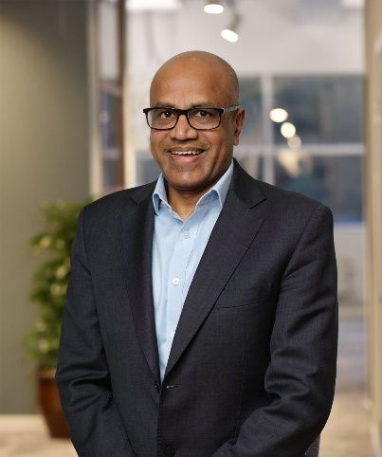  Arun Bansal  Board member since 2020  Born: 1968  Independent Board member  CEO of Adani Airports Holdings Limited  Education: Bachelor of Engineering (Electronics) from University of Jiwaji, India. Postgraduate Diploma in Marketing from Indira Gandhi National Open University, India  Previous positions: Deputy CEO and President of Europe and Latin America and senior international  positions at Ericsson since 1995  Committee in Mycronic: Member of the Remuneration Committee  Shareholding in Mycronic: -
Anna Belfrage  Board member since 2018  Born: 1962  Independent Board member  Education: MSc Business and Economics  Other Board assignments: Chairman of the Board of Cint AB and NOTE AB. Board member of Elopak ASA, Deep Ocean Group AS and Svedab AB/Öresundskonsortiet  Previous positions: CFO Södra Skogsägarna ekonomisk förening 2017-2019, acting CEO of Beijer Electronics Group 2014-2015, CFO Beijer Electronics Group 2011-2014, CFO ABS Group (a division of the Cardo Group) 2004-2010, various roles and positions within Dresser Wayne AB, Obducat AB, Åkerlund & Rausing AB, and auditor at Price Waterhouse 1986-1994  Committee in Mycronic: Chairman of the Audit Committee  Shareholding in Mycronic: - | Katarina Bonde  Board member since 2010  Born: 1958  Independent Board member  Education: MSc, Engineering Physics  Other Board assignments: Chairman of the Board of Stillfront Group AB and Mentimeter AB. Board member of Viaplay Group AB and Aktiebolaget Trav och Galopp (ATG)  Previous positions: CEO of UniSite Software Inc 2000-2003, CEO of Captura International 1997-2000, Marketing Director Dun & Bradstreet Software Inc. 1996-1997, Vice President at Timeline Inc 1994-1995 and CEO of Programator Industri AB 1989-1992  Committee in Mycronic: Member of the Audit Committee  Shareholding in Mycronic: 4,000
Staffan Dahlström  Board member since 2019  Born: 1967  Independent Board member  CEO of HMS Networks AB (publ) since 2009  Education: Data Engineer, MBA  Other Board assignments: Board member of Clavister AB  Previous positions: Co-founder of HMS Networks since 1989  Committee in Mycronic: Member of the Audit Committee  Shareholding in Mycronic: 34,000 | 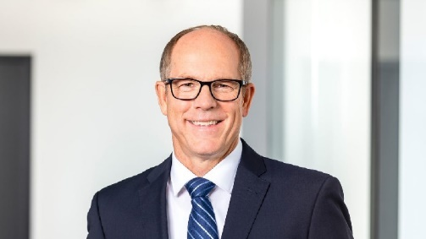  Jens Hinrichsen  Board member since 2024  Born: 1967  Independent Board member  Executive Vice President and General Manager of Automotive & Advanced Analog at NXP Semiconductors  Education: MSc Mechanical Engineering and Business, Technical University Berlin, Germany  Previous positions: 30 years’ experience from the semiconductor industry, starting with various positions at Philips Semiconductors in Europe and Asia, followed by senior positions at NXP Semiconductors in North America and Europe.  Committee in Mycronic: -  Shareholding in Mycronic: -
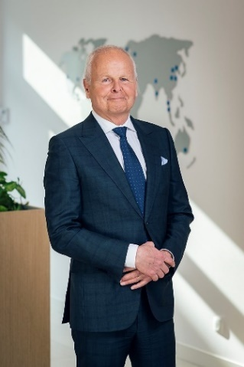

Bo Risberg

Board member since 2022

Born: 1956

Independent Board member

Education: BSc Mechanical Engineering, Queen’s University, Canada and MBA, IMD, Switzerland

Other Board assignments: Board member of Stäubli International AG

Previous positions: 14 years with Hilti Corporation, of which 6 years as COO and 7 years as CEO. In addition thereto 14 years of experience in various roles within ABB

Committee in Mycronic: Member of the Remuneration Committee

Shareholding in Mycronic: 20,000

